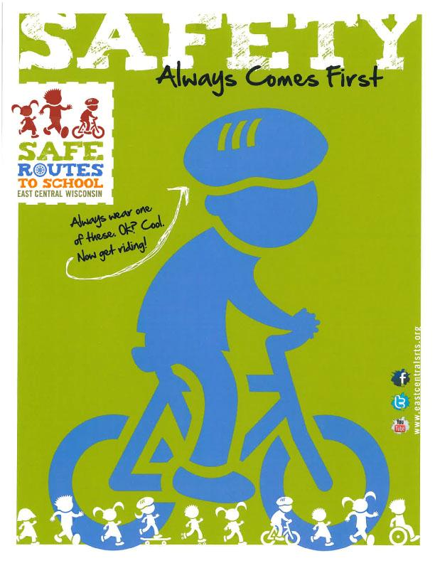

(Insert School or Community Name) will be promoting safe bicycling by (INSERT DESCRIPTION OF EVENT) on (INSERT DATE(S) OF EVENT). Bicycling is a great way to increase physical activity, reduce traffic, help the environment, improve both mental and physical health, and even save money.