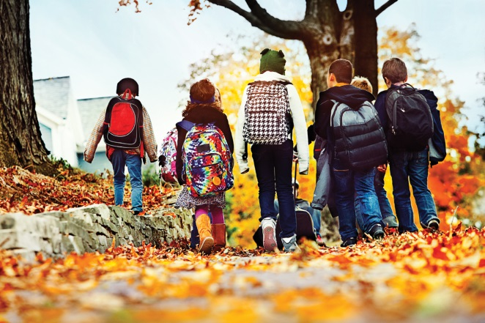

**(Insert school name) Celebrates Walk to School Day October, 2016**

(**Insert your town**), Wisconsin- (**insert your school name**) is celebrating Walk to School Day 2016 on (**insert date**). Walk to School Day brings parents, children and community members together to experience the fun of walking to school together.

Not long ago, walking or biking to school was the norm. Over the last 30 years, the percentage of children biking and walking to school has declined from 50% or more to now closer to about 15%.Today, parents drive as many as 50% of children traveling to school. School bus trips account for an increasing share of the rest. The purpose of International Walk to School Day is to start to reverse these trends.

[**INCLUDE A QUOTE FROM THE SCHOOL PRINCIPAL ABOUT THE IMPORTANCE OF INTERNATIONAL WALK TO SCHOOL DAY TO THE SCHOOL.]**

International Walk to School Day energizes parents and children reminding them of the simple joy of walking to school. It also serves as an opportunity to focus on the importance of physical activity, safety, air quality and building bicycle and pedestrian friendly neighborhoods.

However, increasing physical activity among children, teaching safe walking and biking skills, easing traffic and improving the environment around schools cannot be achieved in one day. Addressing all these problems takes time. International Walk to School Day is just one part of a Safe Routes to School program. Safe Routes to School is an international movement that promotes walking and biking to school in order to improve health, safety and the environment.

Join us on [**date of event**] as we walk to school to promote physical activity, safety and a cleaner environment. To learn more about [**School Name**]’s International Walk to School Day contact [**Organizer’s Name**] at [**Contact Information**].

**About Safe Routes to School**  
[Safe Routes to School (SRTS)](http://www.dot.wisconsin.gov/localgov/docs/srts.pdf) programs encourage children grades K-8 to walk and bike to school by creating safer walking and biking routes. These programs are funded through the revised federal transportation act - [SAFETEA-LU](http://www.fhwa.dot.gov/safetealu/) - signed into law on August 10, 2005. This legislation provides funding to state departments of transportation to create and administer SRTS programs. SRTS programs improve walking and biking travel options, promote healthier lifestyles in children at an early age and decrease auto-related emissions near schools.

Parents and community members will also be able to follow the ECWRPC’s Safe Routes to School program through recently launched social media platforms such as [Facebook](http://www.facebook.com/#!/pages/Safe-Routes-to-School-East-Central-WI/239909732704687), [Twitter](http://twitter.com/#!/mysaferoute), [Flickr](http://www.flickr.com/photos/saferoutestoschoolecw/sets/) and [YouTube](http://www.youtube.com/user/SafeRoutes2SchoolECW). For more information, please visit [www.eastcentralsrts.org](http://www.eastcentralsrts.org/).

**Media Contact**

(Insert name)

(Insert organization)

(Insert address)

(Insert email)

(Insert phone number)