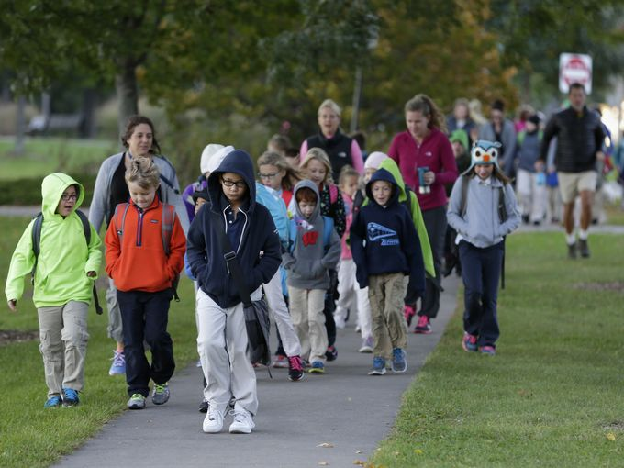

**Walk to School Day**

**2017**

**What is Walk to School Day?**

National Walk to School Day started in 1997 as a one-day event to build awareness for the need of walkable communities. It is now a global event that involves thousands of schools in more than 40 countries walking and biking to school on the same day. What started as a one day event has led to the creation of a year- round Safe Routes to School Program.

**To learn more information go to:**

<http://www.walkbiketoschool.org/>

<http://eastcentralsrts.org/events/your-walk-to-school-day-event>

**Safety Tips While Walking to School**

• Always use sidewalks or paths where available, if there are no sidewalks or paths always walk facing the traffic as far left as possible

• Make eye contact with drivers; do not assume that drivers see you

• Wear bright colored or reflective clothing to make you more visible to drivers

• Stop. Look Left, right, and left again before crossing and always use marked crosswalks and crossing guards when possible

**Benefits of Participating**

• Safer streets

• Healthier active lifestyles

• Reduced traffic congestion around schools

• Brings communities together

• Lower costs

**Parent Newsletter**