Walk to School Day Activity – Corner Captains Booklet
This activity orginated at Jefferson Elementary School in Oshkosh and is a great activity to get kids active and excited about Walk to School Day while at the same time providing them with some valuable safety tips. The idea is relatively simple, just pick out a few locations surrounding your school (these can be street intersections or other locations) and have designated “Corner Captains” at each of the locations to sign the booklets for students. These corner captains can be teachers, police officers, public officials, or other local celebrities. The booklet is totally customizable so you can add the different locations/intersections that you will be using. At Jefferson Elementary after the students get all of the signatures they turn in the booklet which makes them eligible to win one of the Walk to School Day incentives provided by the East Central SRTS Program. This event is a great way to get students active and also can include students that may live too far to actually walk to school. Below you will find the printing instructions for the booklet. If you have any problems printing or any questions at all please feel free to contact a member of the East Central SRTS staff.
Printing Instructions
Layout - Print Type:” 2-Sided”
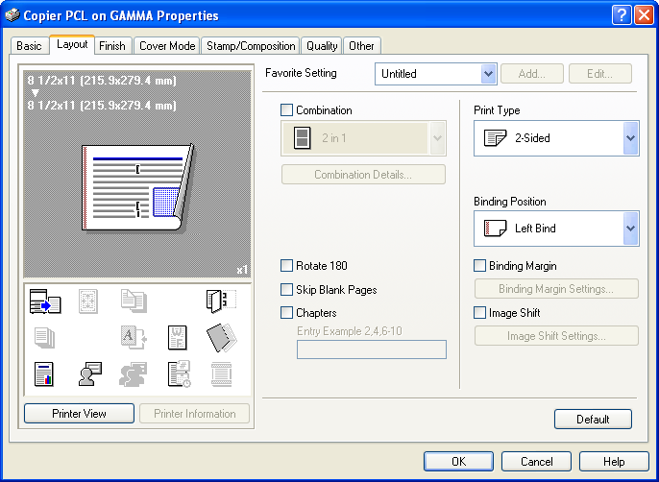

Finish – Check “Center Staple and Fold” (If your printer has this capability)
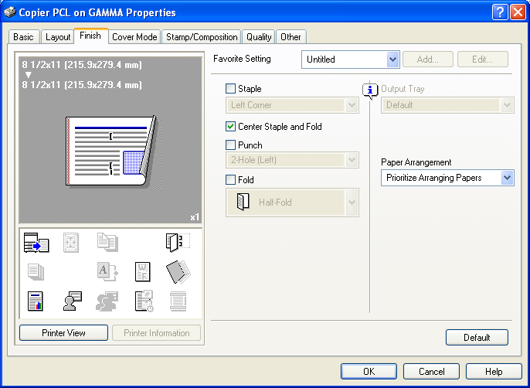
Be sure that: Print on Both Sides “Flip pages on short edge” is selected
